Summer Reading 2021 Grade 3 Required Reading

Required summer reading ANY non-fiction book of interest &

Bones by Jolie Canoli & Jessica Ostrander.

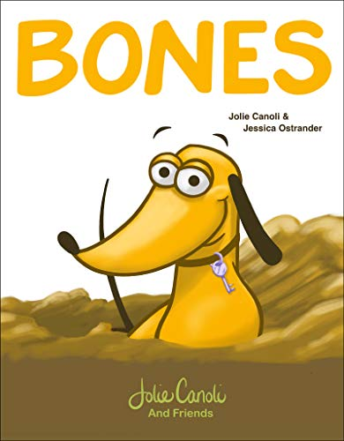

We will be starting the year with a book discussion. Here are some questions to consider while reading Bones over the summer:

★ Who is the main character?
★ What does he have that he loves?
★ What does it do?
★ What happens to it in the book?
★ How does he feel? Why?

Additional Assignments:
★ Practice addition and subtraction
★ Continue working on your Diagnostic on IXL and/or practice working on skills you need to review. (ixl.com/signin/ps185)

