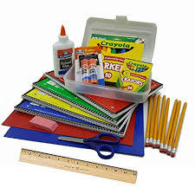 3rd Grade Supply List

Please Note: Children will be carrying supplies to and from school.

Extra mask in a zip lock bag with child’s name on it
Three notebooks
- One for Math and Word Study
- One for Social Studies and Science
- One for Reading and Writing
One Folder
Headphones
Pencil case holder which will contain:
- Crayons
- Black and blue pen
- Ticonderoga pencils
- Sharpener
- Post its preferably lined
- Individual travel size tissues

Books: Please do not have the children read these novels yet
- Absent Author from A-Z Mysteries (Mystery Unit)
- Stone Fox (Narrative Unit)
- Because of Winn Dixie (Character Study)
Please have student bring in 1 fiction book on their level for their independent reading while in school

Classroom Supplies
- 1 package of copy paper
- 1 package of baby wipes
- 1 box of facial tissues
- 1 roll of paper towels
- 1 bottle of hand soap

