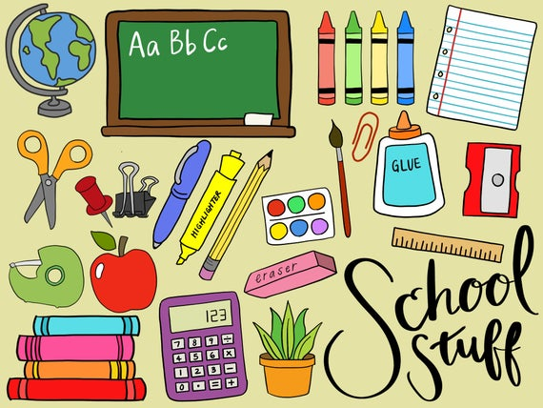

Class 506 Supply List

*Please get your child a Brooklyn Public Library Card if they don’t have one already (This will help throughout the year.)*

Student Supplies:
4 marble notebooks labeled: (TCR, TCW, Math/SS, Science)
2 plastic folders with bottom pockets (1-Blue to be collected, and 1 any color/design)
1 ream of WHITE Hammermill copy paper (8 ½ x 11 size)
10 #2 sharpened pencils
2 blue or black ink pens
1 colored pen for corrections
1 package of different color highlighters
Holder for supplies (soft zipper case)
1 Elmer’s Glue Stick
Washable markers, colored pencils, or crayons
Scissors - 7 or 8 inches
Headphones in a labeled ziploc bag
2 packages of Post-Its (1 large and 1 small)
Whiteboard (or Dry Erase board) 8 ½ x 11 inches
Black OR Colored Expo dry erase markers
*NO Binders or spiral notebooks allowed*

Classroom Supplies:
2 boxes of tissues
1 roll of paper towels
2 boxes of pencils to be collected
2 containers of Clorox Wipes
1 bottle of Hand Sanitizer
1 Package of Gallon OR Quart Ziploc bags

*Make sure your child has a book to read with them on the first day of school.

