Summer 2021 Grade 5 Required Reading

Required summer reading ANY non-fiction book of interest &

Rules by Cynthia Lord.

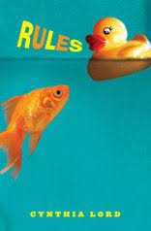

We will be starting the year with a book discussion. Here are questions to consider while reading Rules over the summer:

★ What is a them in this novel's themes?
★ Describe Catherine – use character traits.
★ Overall, in what way is Catherine changed by the end of the book? What does she come to learn about herself and others?
★ If Catherine were to write a rule at the end of the book, what would it be and why?

Additional Assignments:
★ Study your multiplication tables (1-12)
★ Continue working on your Diagnostic on IXL and/or practice working on skills you need to review. (ixl.com/signin/ps185)

